Klarna system error on pin pads

KB0013721

***Klarna System Error on Pin Pads***

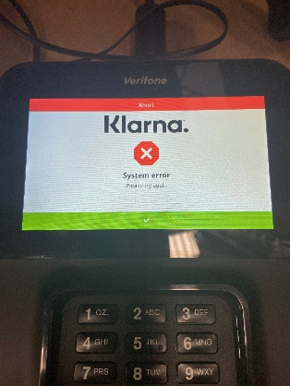

Some stores will encounter an issue in which they will see a **Klarna System Error**

First try clearing any “Stuck” transactions on the pinpad that is getting the error message.

This can be done by having the SM hold 6 + the enter key on the pinpad the entering the PW (166831) to open the configuration menu. Then scroll down and press “Next” then press the “Launch CP App” button. Then select “Klarna” this will prompt them to enter the system PW again (166831) after this scroll down until you see option 10. “Clear Transaction” select this and clear sales.

Then have them back out of the menu and re-attempt the sale.

If the customer has already left a test can be performed by Scanning an item, selecting add tenders, digital payments, Klarna, pressing enter, and waiting for the QR code to appear on the pinpad. As long as the QR code appears then everything is working. The sale can then be canceled.

Also, Check and see if the whole software stack has be pushed down in **VHQ**.

Login VHQ with Company ID **POINTNA-HIBBETT**

go to device search

under brand click either **HB or CG** depending on the store followed by clicking the correct stores number (make sure you click the **"+"** by the store number).

apply filter

after the filter is applied, it will show you the store's pin pads.

Click on **schedule**, then click on **downloads**.

Go to Folder and filter by **Current_Engage_2021Q4**

Push the last 3 packages listed below starting with 4-cp-

